**Block Diagram:**

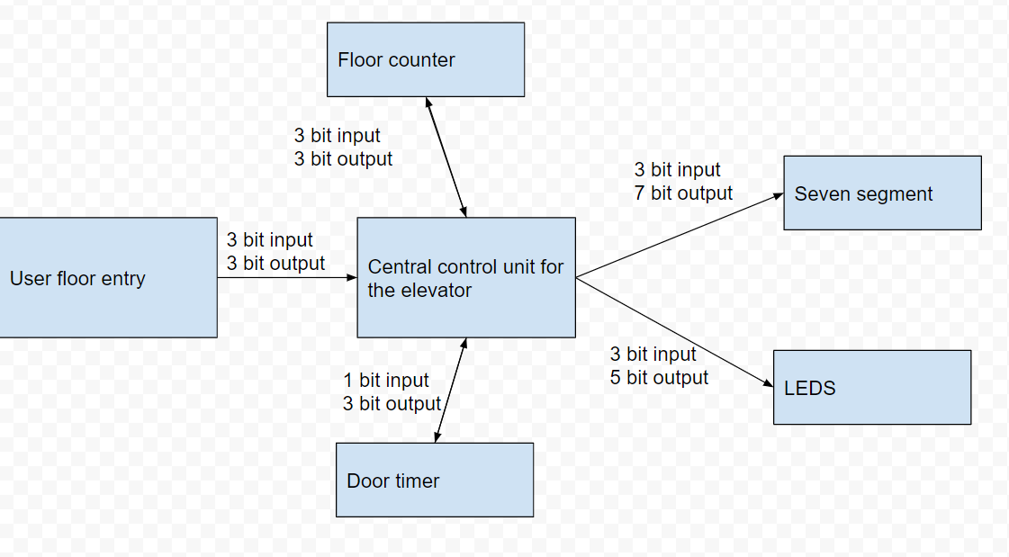

This is my block diagram of my elevator. My elevator will start with a combination of buttons and switches. This will replicate button presses on an elevator. I have called this my user floor entry. There are 5 floors in the building. The input into the user floor entry will be a 3-bit number since that goes up until the number 5. The combination of numbers will then be processed by the control unit of elevator once entered. The door must remain open for 3 seconds. Therefore, there must be a door timer. This will have a clock divider within it for timing. This will be handled by a timer going into the central control unit. The central control will then send out signals to the seven segment and the LEDs to light up accordingly. Assume no one else is using the elevator during operation except one person.

**The components:**

1. User floor entry-
   * 3 bit input- entering keys in
   * 3 bit output- those keys becoming a single for the main unit
2. Fsm or central control unit for the elevator
   * 3 bit input- coming in from the key signal
   * 3 bit output- telling what floor the elevator
   * 3 bit output- telling the door what floor the elevator is currently on
3. Door timer
   * 1 bit input- if door is open
   * 3 bit output- send back a 3 second wait time
4. Floor counter
   * 3 bit input- send a signal to determine the current floor
   * 3 bit output- send back signal to confirm the floor with the central control unit
5. Seven segment
   * 3 bit input- from the current floor from the central
   * 7 bit output- outputting onto the seven segments
6. LEDS
   * 3 bit input- from the current floor from the central
   * 5 bit output- the leds lights up

Timeline:

|  |  |
| --- | --- |
| Date | Task |
| October 16, 2020 | Turn in Project spec and Rough draft |
| October 20,2020 | Project review |
| October 22,2020 | Revisions for Block Diagram, description of components, i/p, o/p, Timeline |
| October 23,2020 | Start building central control unit |
| October 25,2020 | Finish central control unit and start on the elevator button pressing |
| October 26,2020 | Turn in first component |
| October 27,2020 | Start working on the door timer, and the floor counter |
| October 28,2020 | Start to work on the Seven segment path and the LED path of the device |
| October 29,2020 | Finish all components for turn in |
| November 3,2020 | Demonstration project |
| November 4-9, 2020 | Fix project from demo and write report for project |
| November 10, 2020 | Whole Project 1 due |